Bahria University,

Karachi Campus



Course: CSL 320 Operating systems Lab

Term: Spring 2022, Class: BSE- 4(B)

Submitted By:

Abdul Quddos 69984

(Name) (Reg. No.)

Submitted To:

Dr. Rizwan Fazal/Engr. Rahemeen

Signed Remarks: Score:

INDEX

|  |  |  |  |  |
| --- | --- | --- | --- | --- |
| SNO | DATE | LAB NO | LAB OBJECTIVE | SIGN |
| 1 | 7/3/22 | 1 | Introduction to Linux |  |
|  |  |  |  |  |
|  |  |  |  |  |
|  |  |  |  |  |
|  |  |  |  |  |
|  |  |  |  |  |
|  |  |  |  |  |
|  |  |  |  |  |
|  |  |  |  |  |
|  |  |  |  |  |
|  |  |  |  |  |
|  |  |  |  |  |
|  |  |  |  |  |
|  |  |  |  |  |
|  |  |  |  |  |
|  |  |  |  |  |
|  |  |  |  |  |
|  |  |  |  |  |
|  |  |  |  |  |
|  |  |  |  |  |

Bahria University,

Karachi Campus



LAB EXPERIMENT NO.

1

LIST OF TASKS

|  |  |
| --- | --- |
| TASK NO | OBJECTIVE |
| 1 | By using the command line shell interface, practice the commands given in this lab. Write briefly about the usage of each command. |
| 2 | By using gedit, open a text editor and write the C program That print your name. Save the written file as “name.c”. In order to compile and execute the output file, do the following:   * $ gcc - o name name.c * $ ./name |
| 3 | Make changes within the above program to display a new output text as given below. Write down the developed program.   * Hello World! I am studying Operating Systems. * My name is “Enter your name”. * My registration number is “Enter your registration number”. * I belong to Bahria University Karachi Campus. |
|  |  |
|  |  |
|  |  |
|  |  |
|  |  |
|  |  |
|  |  |

Submitted On:

(Date: 21/3/22)

**LAB # 01**

**Task # 01:**

**By using the command line shell interface, practice the commands given in this lab. Write briefly about the usage of each command.**

**Task#1.1:**

**man command:**

**Output:**



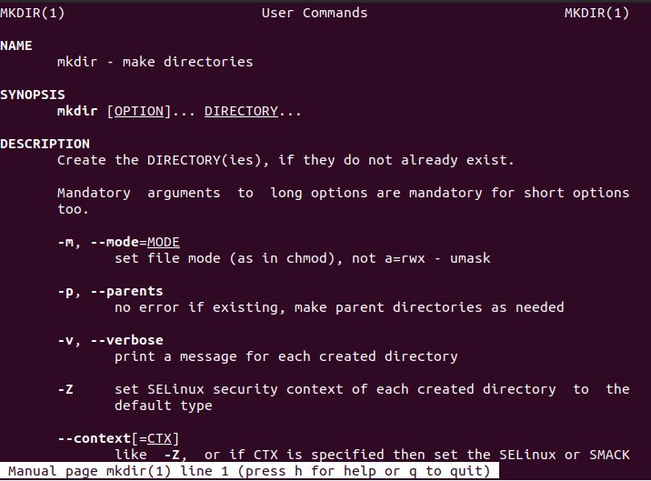

* **It is usually used for help.**

**Task#1.2:**

**Command: date**

**Output:**



* **It shows the current date in OS.**

**Task#1.3:**

**Command: pwd**

**Output:**



* **It shows present working directory**

**Task#1.4:**

**Command: mkdir directory**

**Output:**



* **It makes a directory in a current specified directory**

**Task#1.5:**

**Command: mkdir –p dir**

**Output:**



* **Creates directory in hierarchal manner in a specified directory**

**Task#1.5:**

**Command: mkdir –v folder1**

**Output:**



* **Creates directory in a specified directory with information**

**Task#1.6:**

**Command: ls**

**Output:**



* **List all the directories and files created in a specified directory.**

**Task#1.7:**

**Command: ls -l**

**Output:**

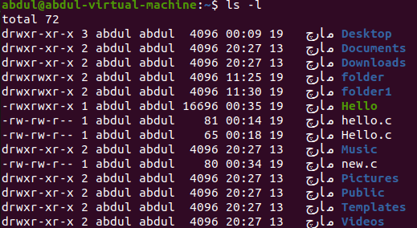

* **Displays the content of a directory in a long format and with details.**

**Task#1.8:**

**Command: ls -a**

**Output:**

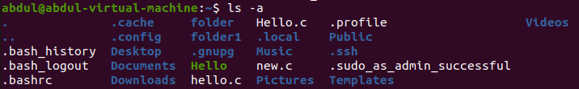

* **Displays the content with hidden contents in a specified directory**

**Task#1.9:**

**Command: ls -h**

**Output:**



* **Displays the content in a human readable form**

**Task#2:**

**By using gedit, open a text editor and write the C program That print your name. Save the written file as “name.c”. In order to compile and execute the output file, do the following:**

* **$ gcc - o name name.c**
* **$ ./name**

**Output:**



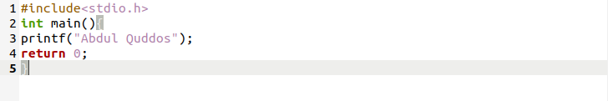 

**Task#3:**

**Make changes within the above program to display a new output text as given below. Write down the developed program.**

* **Hello World! I am studying Operating Systems.**
* **My name is “Enter your name”.**
* **My registration number is “Enter your registration number”.**
* **I belong to Bahria University Karachi Campus.**

**Output:**

